SAT/ACT/ASVAB FREE TEST PREP
THROUGH EDMENTUM

Follow These Steps to Add Any Course(s) in your district Edmentum account for Test Prep:
- Go to clever.com/in/stjohns
- Use your typical student number username and password to login to Edmentum
- Click the "Self-Enroll" button at the bottom of the screen.
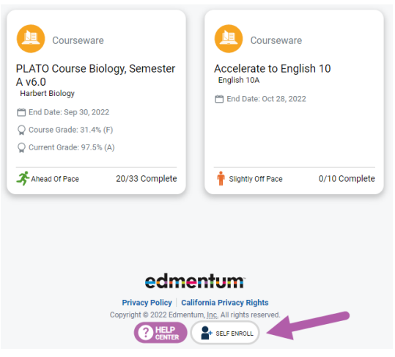
- Enter the Self-Enroll ID and password for the course you want to take (see Enroll ID list by school below). Password for each course is “sjvs”.
- Click "Verify Your Information".
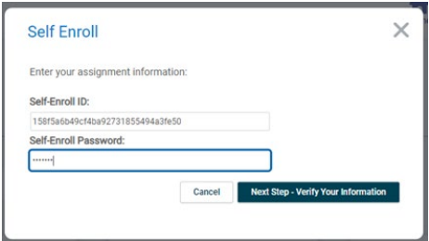
- If correct, click "Complete Your Registration".
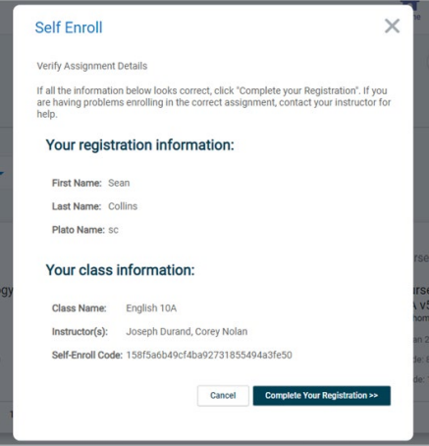
- Note: When you return to the home screen, you may not see the new course. If so, click the Home button again, or log out and log in again to see the new course.

Course Codes by School and Course

Bartram Trail
Course | Course Code
SAT Mathematics | a041904c5a92f4a095c6de85c34fd3a0
SAT Writing & Language | 9a4ea051c517dabfd7a68315144a1e1b
SAT Reading | b2147b265d1ec675b8c37ea682ae94f8
ACT Mathematics | 3ed8ac1ee4b37a4d0d3370eb5f9ae07b
ACT Science | 6a135780d48bd8f926cfb4f4f66c866e
ACT English | 5831179f0b530f3453c9825b595650db
ACT Reading | b9da28960355c92133c2ba78a06468c1
ASVAB Mathematics | 784515ad6377dda30776144f3b838631
ASVAB Technology and General Science | edd88cdae56c765cd976121b439f2f33  3fd2f500fae0e4545378c62adacaf5a4
ASVAB Word Knowledge & Paragraph Comprehension | 9fe370ff59d0f7490cfdc254466f1377

