SAT/ACT/ASVAB FREE TEST PREP
THROUGH EDMENTUM

Follow These Steps to Add Any Course(s) in your district Edmentum account for Test Prep:
- Go to clever.com/in/stjohns
- Use your typical student number username and password to login to Edmentum
- Click the "Self-Enroll" button at the bottom of the screen.
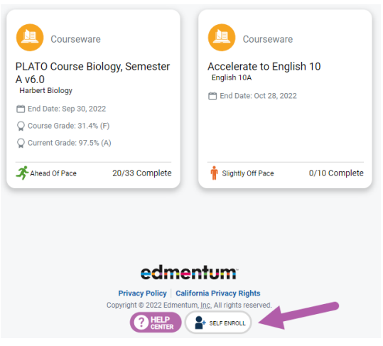
- Enter the Self-Enroll ID and password for the course you want to take (see Enroll ID list by school below). Password for each course is “sjvs”.
- Click "Verify Your Information".
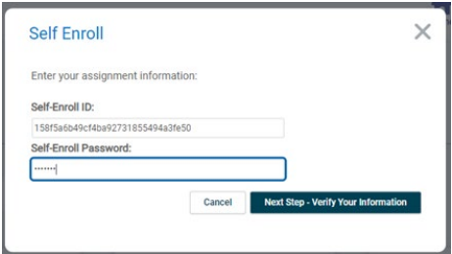
- If correct, click "Complete Your Registration".
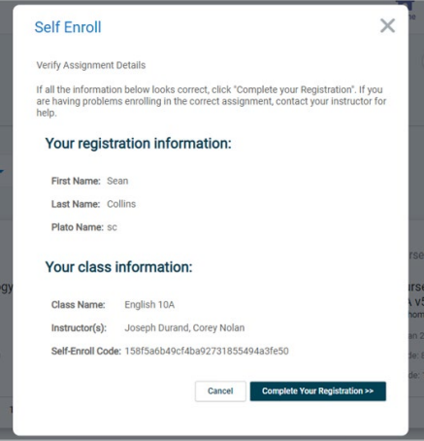
- Note: When you return to the home screen, you may not see the new course. If so, click the Home button again, or log out and log in again to see the new course.

Course Codes by School and Course

Beachside
Course | Course Code
SAT Mathematics | 8dcb95b20256e0b6a3f4d90857358e8e
SAT Writing & Language | c45724a9d0fbd5cc5f4a26bec22f291a
SAT Reading | 69fea2925a7e291a58874f4ae59a509d
ACT Mathematics | e519447236ec6ae56ae4707bcf1b056c
ACT Science | 98f1666f896b9969bfd80f2f7bb3123b
ACT English | 16db2089809f0255fbce433ae1998042
ACT Reading | 6721cd51bac58f58b11cdcb92da44809
ASVAB Mathematics | 0e5bad160e8d7436f9d7a2353b97eabb
ASVAB Technology and General Science | 890d5bed34fee5536881f61a97450fdc  3b521c1c4f05f83a7d2cbfbacc178b3e
ASVAB Word Knowledge & Paragraph Comprehension | 73ec6cc85158472ee59c72888585210b

