SAT/ACT/ASVAB FREE TEST PREP
THROUGH EDMENTUM

Follow These Steps to Add Any Course(s) in your district Edmentum account for Test Prep:
- Go to clever.com/in/stjohns
- Use your typical student number username and password to login to Edmentum
- Click the "Self-Enroll" button at the bottom of the screen.
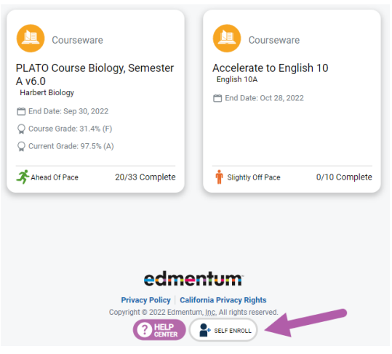
- Enter the Self-Enroll ID and password for the course you want to take (see Enroll ID list by school below). Password for each course is “sjvs”.
- Click "Verify Your Information".
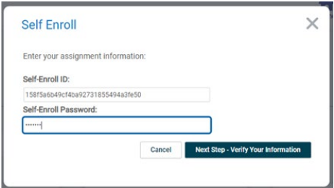
- If correct, click "Complete Your Registration".
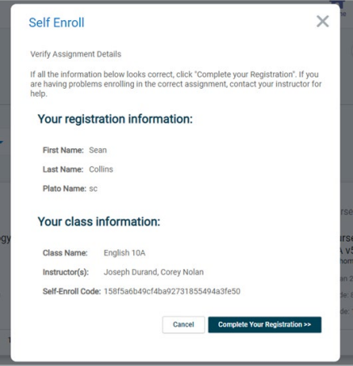
- Note: When you return to the home screen, you may not see the new course. If so, click the Home button again, or log out and log in again to see the new course.

Course Codes by School and Course

Creekside
Course | Course Code
SAT Mathematics | 25f3add9105f3f8ffa085f572530e94c
SAT Writing & Language | 5a8e18bd65d41536b707e513a1ccdf0f
SAT Reading | c492cb76d9064e64204203e5be543d12
ACT Mathematics | 6f9a7b3c006d4c51f6a96866704d1520
ACT Science | c85a2819641c10ff199c2c2224042afc
ACT English | c56eefd686d5de86ff12a167d24fa467
ACT Reading | e24b536c6f1d4a078ab2837d7a6e2524
ASVAB Mathematics | 4a4c8c7f1aca41882b60a8f5b41a3532
ASVAB Technology and General Science | 3a087dbf7e28370855811901b07a8052  1ded8876c144dafc6feafea31b9d7a88
ASVAB Word Knowledge & Paragraph Comprehension | 1a2d5186480b0a629bffdb26b66ef677

