SAT/ACT/ASVAB FREE TEST PREP
THROUGH EDMENTUM

Follow These Steps to Add Any Course(s) in your district Edmentum account for Test Prep:
- Go to clever.com/in/stjohns
- Use your typical student number username and password to login to Edmentum
- Click the "Self-Enroll" button at the bottom of the screen.
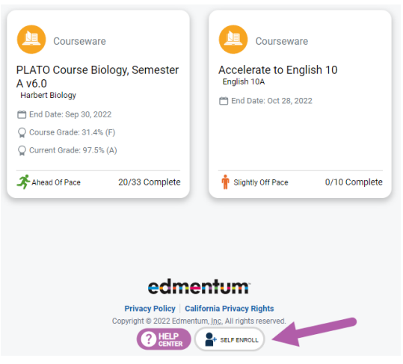
- Enter the Self-Enroll ID and password for the course you want to take (see Enroll ID list by school below). Password for each course is “sjvs”.
- Click "Verify Your Information".
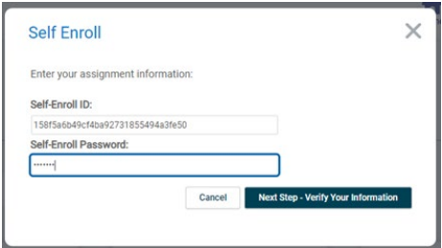
- If correct, click "Complete Your Registration".
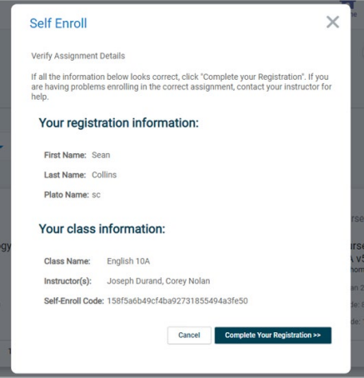
- Note: When you return to the home screen, you may not see the new course. If so, click the Home button again, or log out and log in again to see the new course.

Course Codes by School and Course

Nease
Course | Course Code
SAT Mathematics | e27a82f5b26f51ad1510ed72e4ce57e7
SAT Writing & Language | cf69b1ec7d64528a37794bcea2d59f21
SAT Reading | 771e44bddb38a828cfa29afa84e5d47a
ACT Mathematics | 9421fa5c68213be938518c89cb6885b1
ACT Science | 9acef5aa662ec15f18adf8842c55d6c8
ACT English | 2d912cb7924958b593e5801866982fdf
ACT Reading | 5207d2d1ba8557330d64fceb7d3d04ce
ASVAB Mathematics | 8aac102788a5441582deb69e934251f3
ASVAB Technology and General Science | 1bf70af458cc7a2f2224f4a1c3bcfa33  ff207d868ddd7955d50038c590bdf8e9
ASVAB Word Knowledge & Paragraph Comprehension | 4d369bd7b6978bfa863f4cd5998cdfc5

