SAT/ACT/ASVAB FREE TEST PREP
THROUGH EDMENTUM

Follow These Steps to Add Any Course(s) in your district Edmentum account for Test Prep:
- Go to clever.com/in/stjohns
- Use your typical student number username and password to login to Edmentum
- Click the "Self-Enroll" button at the bottom of the screen.
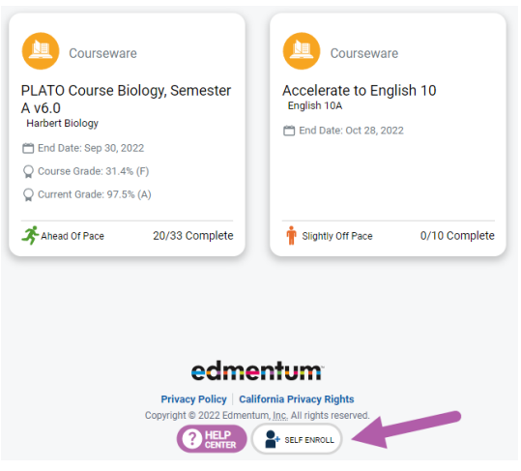
- Enter the Self-Enroll ID and password for the course you want to take (see Enroll ID list by school below). Password for each course is “sjvs”.
- Click "Verify Your Information".
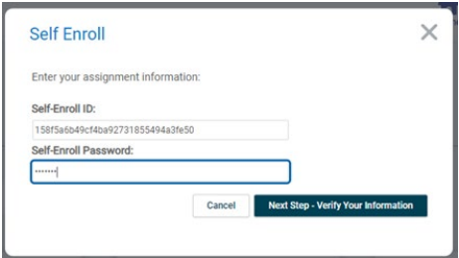
- If correct, click "Complete Your Registration".
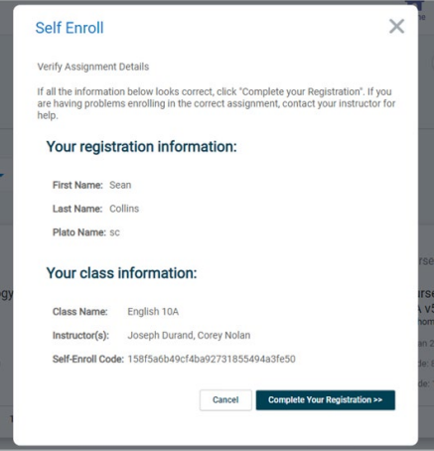
- Note: When you return to the home screen, you may not see the new course. If so, click the Home button again, or log out and log in again to see the new course.

Course Codes by School and Course

Pedro
Course | Course Code
SAT Mathematics | cf3d36fcf322163c21dd31d74e7fc09b
SAT Writing & Language | 108db13d2f4b2bb960776103f1f80645
SAT Reading | fc9f92c45f930f881436ad12ffc37c18
ACT Mathematics | 7c40dfce459e8d369697c781de9f0ff7
ACT Science | 74a0c1e8b9ba9072e34c0e8e317694aa
ACT English | 1b426a29798fa2f6162ed1a55be4347d
ACT Reading | 8816e575885b5673a118037b7589d3bd
ASVAB Mathematics | 4b45ae8c970c896329ac4424388699f1
ASVAB Technology and General Science | 671802b1d83a4e2726b5c1c35b8a7a41  82108b093684fa8bc687ea89343c04e0
ASVAB Word Knowledge & Paragraph Comprehension | 73fefe45a65da7856aaf2b58f14b3e22

