SAT/ACT/ASVAB FREE TEST PREP
THROUGH EDMENTUM

Follow These Steps to Add Any Course(s) in your district Edmentum account for Test Prep:
- Go to clever.com/in/stjohns
- Use your typical student number username and password to login to Edmentum
- Click the "Self-Enroll" button at the bottom of the screen.
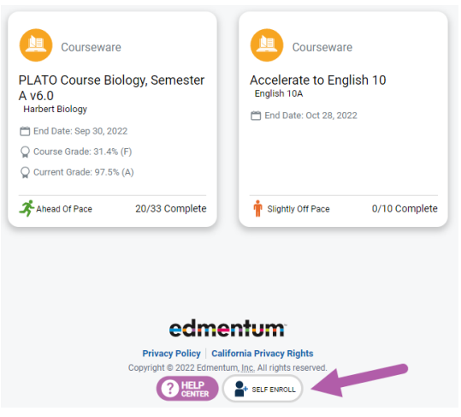
- Enter the Self-Enroll ID and password for the course you want to take (see Enroll ID list by school below). Password for each course is “sjvs”.
- Click "Verify Your Information".
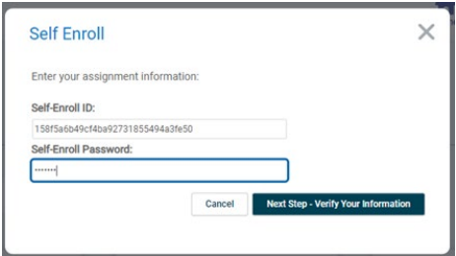
- If correct, click "Complete Your Registration".
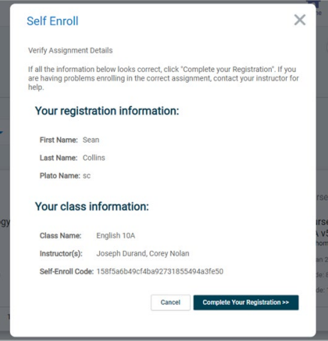
- Note: When you return to the home screen, you may not see the new course. If so, click the Home button again, or log out and log in again to see the new course.

Course Codes by School and Course

Ponte Vedra
Course | Course Code
SAT Mathematics | cbcb0ef7bede2c865a8d0be17d25e2a4
SAT Writing & Language | 20d759900eafea692dfa697bcff45cda
SAT Reading | 24635d685d86d659d523c18d29f851a4
ACT Mathematics | 3979c1a466a56c740afee885fe6f74b0
ACT Science | 021c6925db263643a4c5ed4869c7fdbb
ACT English | 7964320bb081025801bc1c370365276c
ACT Reading | 53844a6770527320fa3514fbbb91202c
ASVAB Mathematics | 951cd5710c97cc0a28acf4c19f35935e
ASVAB Technology and General Science | 33d9fc54f97c465de4940387b3503dab  6ad0f7376bbeca491543c8995a4cf158
ASVAB Word Knowledge & Paragraph Comprehension | 5b374cc0763eaa95e5e9a57776c13ee6

