SAT/ACT/ASVAB FREE TEST PREP
THROUGH EDMENTUM

Follow These Steps to Add Any Course(s) in your district Edmentum account for Test Prep:
- Go to clever.com/in/stjohns
- Use your typical student number username and password to login to Edmentum
- Click the "Self-Enroll" button at the bottom of the screen.
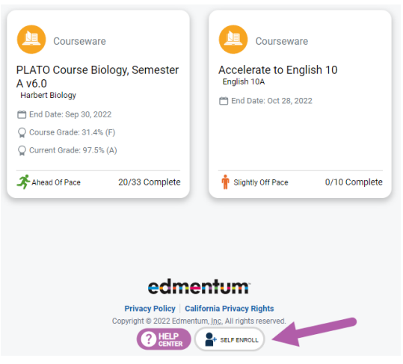
- Enter the Self-Enroll ID and password for the course you want to take (see Enroll ID list by school below). Password for each course is “sjvs”.
- Click "Verify Your Information".
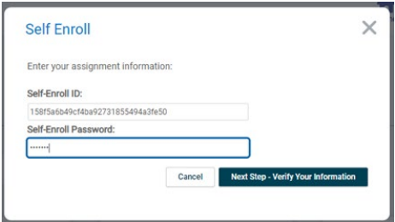
- If correct, click "Complete Your Registration".
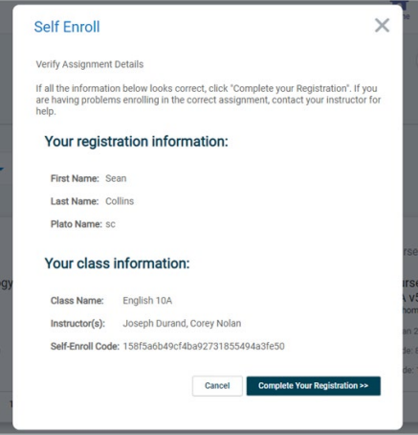
- Note: When you return to the home screen, you may not see the new course. If so, click the Home button again, or log out and log in again to see the new course.

Course Codes by School and Course

St. Johns Virtual
Course | Course Code
SAT Mathematics | 9f55168009461f094c4ba08c015642e8
SAT Writing & Language | fbb012c5a0f5e97b38e79c68afa4af1d
SAT Reading | 0711d6a6fc09a6fe79aaeb70bf87bac4
ACT Mathematics | 740c02509882b3ca931f0e46744d4ea1
ACT Science | 5e546da241124582607764152a42c4c0
ACT English | 57945369efc4ed30d8c9522b6053edd9
ACT Reading | b21f2567a98b0744dfbbd92a9329dc65
ASVAB Mathematics | 35687118e13790020d818553f72ace01
ASVAB Technology and General Science | c71bc3a8b7ac267277a2be1195e87e65  71b6fefb64c049b9115e9e7ac598bf6f
ASVAB Word Knowledge & Paragraph Comprehension | 5c5da700254167d752f3eb43278398e2

