SAT/ACT/ASVAB FREE TEST PREP
THROUGH EDMENTUM

Follow These Steps to Add Any Course(s) in your district Edmentum account for Test Prep:
- Go to clever.com/in/stjohns
- Use your typical student number username and password to login to Edmentum
- Click the "Self-Enroll" button at the bottom of the screen.
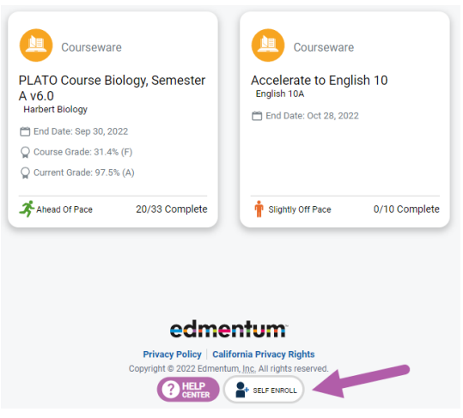
- Enter the Self-Enroll ID and password for the course you want to take (see Enroll ID list by school below). Password for each course is “sjvs”.
- Click "Verify Your Information".
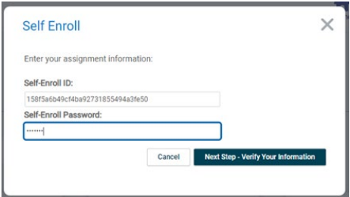
- If correct, click "Complete Your Registration".
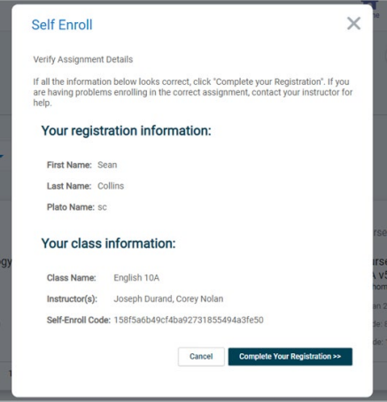
- Note: When you return to the home screen, you may not see the new course. If so, click the Home button again, or log out and log in again to see the new course.

Course Codes by School and Course

SAHS
Course | Course Code
SAT Mathematics | 4b50b0b31426e5e160937ef7e053eb76
SAT Writing & Language | 20dea7485828fd7aad4971bf91a05581
SAT Reading | 4928a13eb786e02c7f2980505ab01766
ACT Mathematics | 4e1420be031d5c782c285a49f3565a24
ACT Science | 5d4256ab5e260f86c2364f153424f7b1
ACT English | a0ac4ab17a52c1919f4d71f68648235e
ACT Reading | 3ac15bf73032fbaa43f60385f6b415fb
ASVAB Mathematics | 33d90d846aa26f56681b4514005de25f
ASVAB Technology and General Science | e4acf37b3020b3ed44cfd89adcbb16de  df3c3058e6d28a08ee5d4f2f1cad56c8
ASVAB Word Knowledge & Paragraph Comprehension | a564508c00d09eedbed36011a64e7121

