SAT/ACT/ASVAB FREE TEST PREP
THROUGH EDMENTUM

Follow These Steps to Add Any Course(s) in your district Edmentum account for Test Prep:
- Go to clever.com/in/stjohns
- Use your typical student number username and password to login to Edmentum
- Click the "Self-Enroll" button at the bottom of the screen.
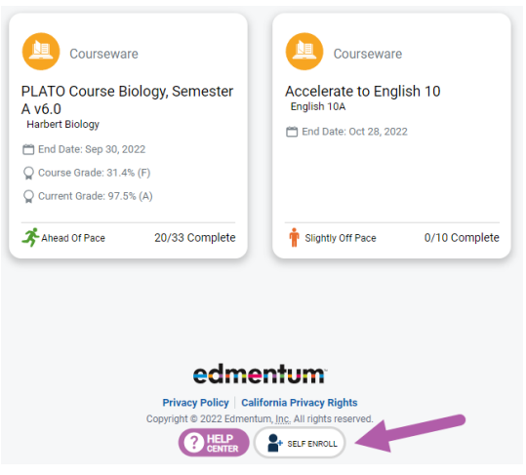
- Enter the Self-Enroll ID and password for the course you want to take (see Enroll ID list by school below). Password for each course is “sjvs”.
- Click "Verify Your Information".
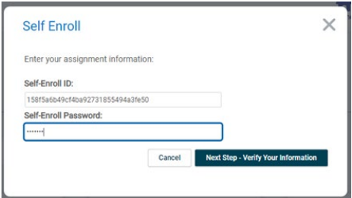
- If correct, click "Complete Your Registration".
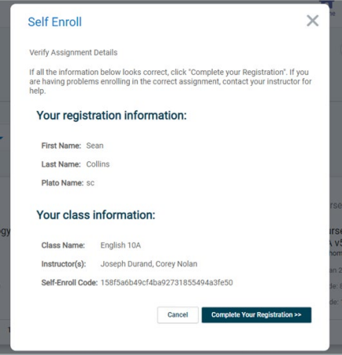
- Note: When you return to the home screen, you may not see the new course. If so, click the Home button again, or log out and log in again to see the new course.

Course Codes by School and Course

Tocoi
Course | Course Code
SAT Mathematics | 914bb311f1420ffad045e92f4f6e5600
SAT Writing & Language | a6aeb99a463456eb0161b008e5144ae4
SAT Reading | 841a145308cadbd40a13f3cf0c31890d
ACT Mathematics | f8a77b4ffe9643605fb64161a0eab370
ACT Science | 3d3ce8fd10ff263e8032b17f60fed42f
ACT English | 7f39487f7824eea60712f9de51323876
ACT Reading | f6bc91e05ea25634c2acc2468887cd32
ASVAB Mathematics
ASVAB Technology and General Science
ASVAB Word Knowledge & Paragraph Comprehension

